- MathOperation
Create a class MathOperations, which should have 3 times method Add(). Method Add() have to be invoked with:
Add(int, int): int
Add(double, double, double): double
Add(decimal, decimal, decimal): decimal
You should be able to use the class like this:
StartUp.cs
public static void Main()
{
MathOperations mo = new MathOperations();
Console.WriteLine(mo.Add(2, 3));
Console.WriteLine(mo.Add(2.2, 3.3, 5.5));
Console.WriteLine(mo.Add(2.2m, 3.3m, 4.4m));
}
Examples
Input | Output
5
11
9.9

Solution
Created MathOperation class should look like this:

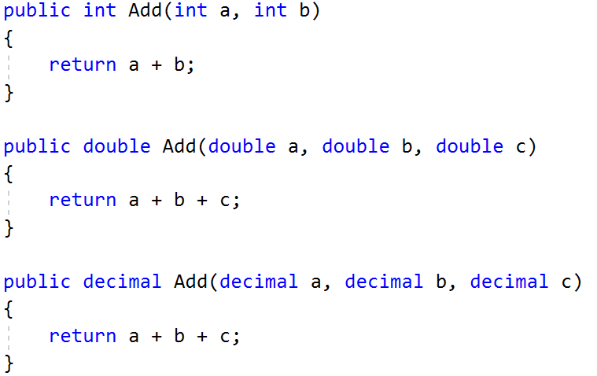

- Animals
Create a class Animal, which hold two fields:
name: string
favouriteFood: string
Animal have one virtual method ExplainMyself(): string
You should add two new classes Cat and Dog. There override ExplainMyself() method by adding concrete animal sound on new line. (Look at examples below)
You should be able to use the class like this:
StartUp.cs
Animal cat = new Cat("Pesho", "Whiskas");
Animal dog = new Dog("Gosho", "Meat");

Console.WriteLine(cat.ExplainMyself());
Console.WriteLine(dog.ExplainMyself());
Examples
Input | Output
I am Pesho and my fovourite food is Whiskas
MEEOW
I am Gosho and my fovourite food is Meat
DJAAF
Solution
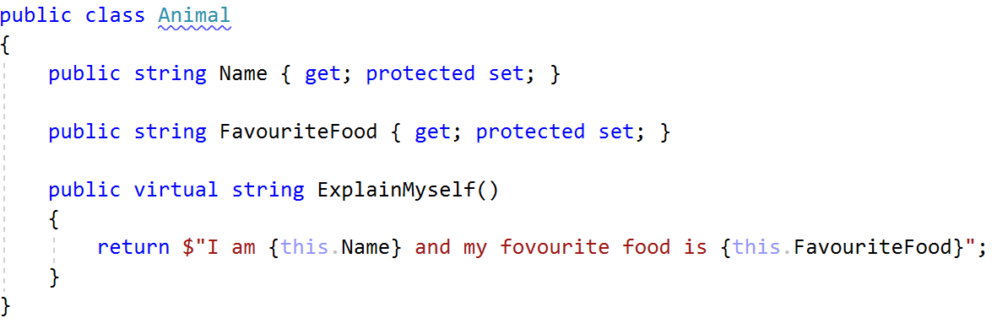
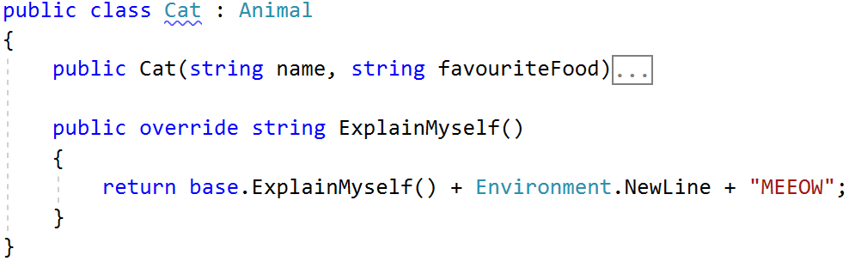

- Shapes
Create class hierarchy, starting with abstract class Shape:
Abstract methods:
calculatePerimeter(): doulbe
calculateArea(): double
Virtual methods:
Draw(): string
Extend Shape class with two children:
Rectangle
Circle
Each of them need to have:
Fields:
height and width for Rectangle
radius for Circle
Encapsulation for this fields
Public constructor
Concrete methods for calculations (perimeter and area)
Override methods for drawing

